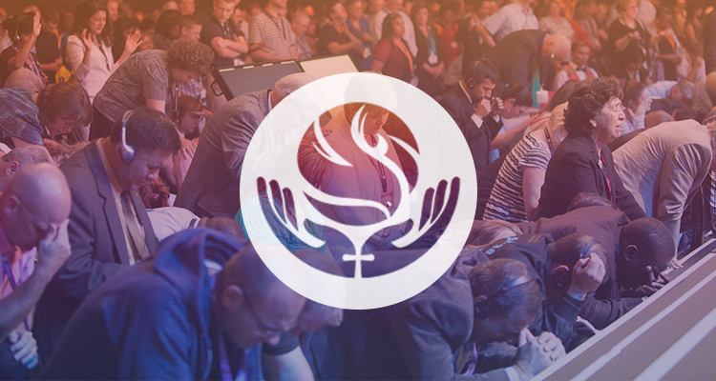
“Bear Much Fruit”
John 15:8
Team Day
September 30th 2017
Location: Indiana Wesleyan University
(Lexington, KY campus) 2530 Sir Barton Way, Lexington, KY 40509
Time: 8:30 – 1:00
Cost: $10

EKD Team Day Schedule

Registration/Continental Breakfast 8:30– 9:00

Opening Session 9:05 – 10:05

Break Out Session #1 10:15 – 11:00

Break/Refreshments will be served 11:00 – 11:30

Break Out Session #2 11:35 – 12:20

Closing Session 12:30 – 1:00

Lunch on your own/Travel home

“Bear Much Fruit”
John 15:8
Team Day
Registration Form

Church Name: _______________________________________________
# Attending: _________________________

Below please check off which Break Out Session you are registering for and how many will be attending each:

______ NYI
______ NMI- Special Speakers- The Rahmat’s
______ Dr. Woody Stevens, Global SDMI Director
______ Rob Steinbrook & Dan Salyers from Summit Nazarene ... Small Group Ministry

